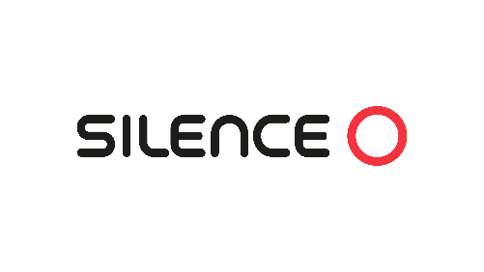

**SILENCE UKs S04 NANOCAR LEADS THE CHARGE**

**Solihull UK, West Midlands**

**8 April 2024**

Silence UK has been creating waves up and down the country with its compact S04 Nanocar.  Holding its own amongst global manufacturers, and leading the way with its innovative battery swapping technology, the Silence S04 has been standing shoulder-to-shoulder with its peers, and it's no surprise its caught the interest of media.

With [TechRadar](https://www.techradar.com/vehicle-tech/hybrid-electric-vehicles/the-6-most-exciting-evs-from-the-geneva-motor-show-2024-from-renault-to-byd) rating it one of 'The 6 most exciting EVs from the Geneva Motor Show', highlighting it's unique petite, manoeuvrable and multi-person design, "it can fit in designated motorcycle parking bays, yet it has air conditioning and a place to house and charge a smartphone." To the high praise received from [Electrifying.com](https://www.electrifying.com/blog/article/new-nano-car-offers-92-mile-range-for-15-995-and-could-become-new-seat) for both the driving range, storage capacity, and top speed of 52mph.  The Silence S04 Nanoar is making its mark on enthusiastic, and intrigued EV audiences, not only for its technical creativity but also for its 'creature comforts'.

It's no wonder then, that there were an unprecedented number of test drives taken when the S04 Nanocar was revealed to a London EV enthusiast audience at the recent Everything Electric Show.

**Andy Fenwick, Managing Director of Silence UK said** "Having the opportunity for customers to talk to the Silence Team about the Nanocar S04 and then having the chance to test drive it, created a truly unique and joyful experience for many.

As a business, the technology in the S04 Nanocar and its sister Scooter range is second to none - however you can't put a price on speaking to people in person.  This was underlined by the feedback we received, and the number of happy and informed customers we spoke to at the Everything Electric Show".

'The Future of Urban Mobility' as Paul Hadley from[motoverso.com](https://www.motorverso.com/introducing-the-silence-s04-nano-car-the-future-of-urban-mobility/), referred to the S04, is as 'fun to drive' as it is 'testament to innovative engineering and a vision for a greener future', and as Silence paves the way in micro-mobility with its eco-conscious Nanocar, and Scooter range, you can be sure the early interest in Silence its just the beginning of an electric evolution.

END:

For further information contact:

Andy Fenwick, 07971 287295, andy.fenwick@silenceuk.com

About **SILENCE**

Established in 2012, SILENCE is the leading manufacturer of electric scooters in Europe. The SILENCE product range comprises the S01 and S02 electric scooters with 125cc and 50cc equivalent power ratings. Prices for the scooter range start from £3,325 OTR.

The SILENCE mission is to accelerate the change towards sustainable urban mobility. All SILENCE products, including batteries, are designed, engineered, and assembled in Barcelona. To facilitate the launch of the S04, SILENCE have acquired and facilitized an all-new production facility with an annual production capacity of 100,000 vehicles.

SILENCE is wholly owned by ACCIONA, a leading greenfield developer and operator of sustainable Energy & Infrastructure assets. ACCIONA provide innovative, sustainable, and impactful solutions globally, operating in more than 40 countries worldwide. The company has been carbon neutral since 2016. ACCIONA made sales of €11,195 million in 2022.